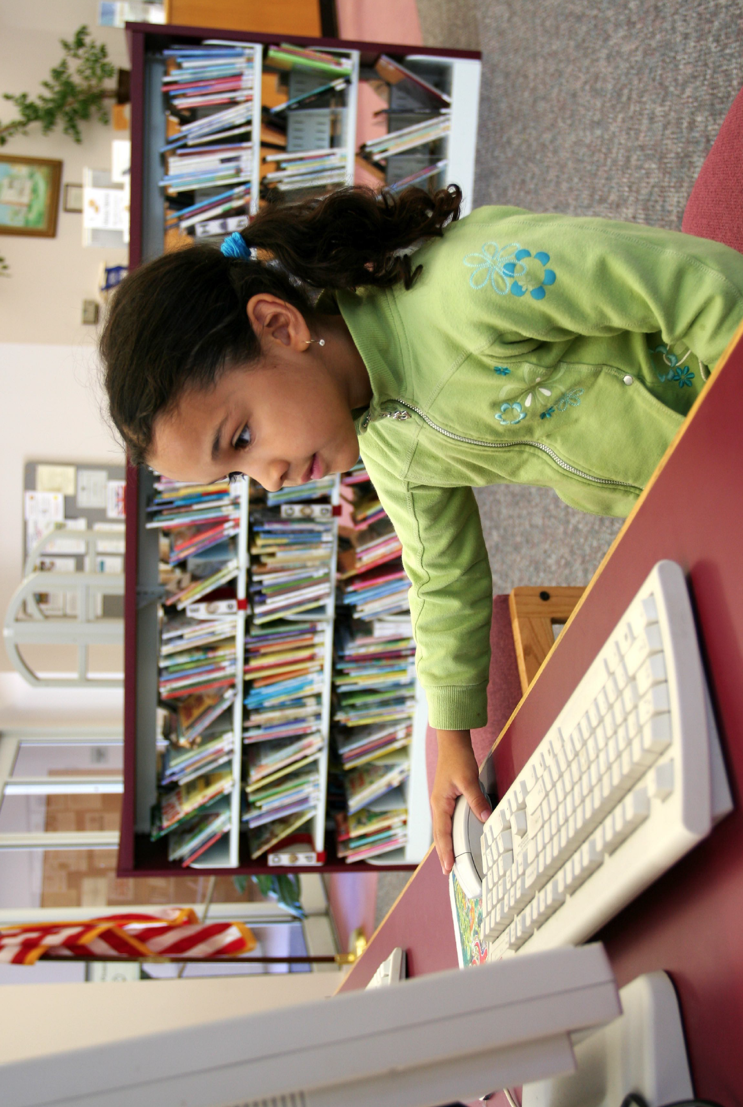
Do you know a child entering kindergarten who is young for the grade?
Children born in August, September, October, November and starting kindergarten may be eligible for a research study.
The focus of the study is to learn how to support children who enter kindergarten and are the youngest in the grade (those born in the months immediately preceding the school entry cut-off). as they are at risk for such outcomes as grade retention, referral to special education, and being diagnosed with attention deficit/hyperactivity disorder.
- If a child qualifies for the study, the child will be randomly assigned to:
  - (1) An intervention to support the student in the classroom in the Fall.
Or
  - (2) An intervention to support the student in the classroom in the Winter.
Or
  - (3) Kindergarten as usual.

- A school psychologist will work with teachers and families to provide positive behavior supports, set goals for the child to help make progress, and work with the teacher to make sure progress monitoring is based on the child’s own growth, rather than relative comparisons to other students.
- Consultation meetings and goal setting will be held via Zoom with a school psychologist.
- There is no fee for participating in this study. All progress monitoring reports and treatments are provided for free as part of the study.
- Teachers receive a $25 gift card for completing the brief ratings of student behavior during Fall, Winter, Spring and during Fall of first grade.
If you have any questions or if you would like to have a meeting to further discuss the project, please feel free to contact Dr. Greg Fabiano, Professor Clinical Psychology at FIU and Principal Investigator of the study at gfabiano@fiu.edu, 716-359-7823

